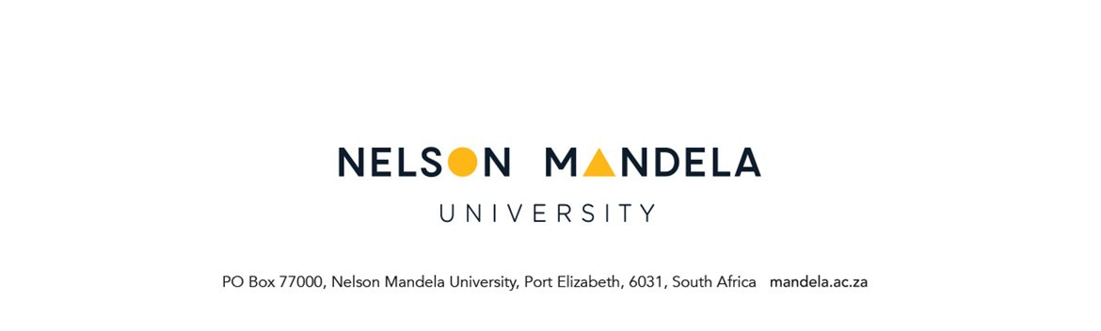
AMENDMENTS TO MODULE DETAILS
(CANCELLATIONS, ADDITIONS, CHANGE OF OFFERING TYPE)

PERSONAL DETAILS OF APPLICANT

STUDENT NUMBER | DEGREE/DIPLOMA
SURNAME | FULL NAMES
STUDY ADDRESS | TELEPHONE NUMBERS
Code: | Home:  Work:  E-mail:

IMPORTANT COMPULSORY CHECKLIST
mark with X
Are you an NSFAS funded student? | Yes | NO
If you are an NSFAS funded student, are you aware of/have read NSFAS guidelines and financial implications of the requested amendment?  For example  - That NSFAS may/may not fund the module addition if upload of student data has been submitted to NSFAS by the university for payment  - Your allowance might have financial implications if the cancellation(s) results in less than 60 credits | Yes | NO
Total credits for the requested cancellation
Please note that a “Change of Registration Detail” fee must be paid if this request is received after the published closing date for registration changes.

MODULE(S) CANCELLATION
MODULE CODE | CANCELLATION REASON | CANCEL CODE  Office use

______________________ ______________________ ________________________
Student Signature Staff signature Date

MODULE ADDITION |  | CHANGE OF OFFERING TYPE
MODULE CODE | FT OR PT | MODULE CODE | FT OR PT

………………………………… .……………………………. ………………….……
Student Signature Staff signature Date

EXTRACT FROM NSFAS GUIDELINES

Funding Rule
4.5.4.3 The N period of study equates to the minimum time required to complete a qualification.
4.5.4.5 The N+1 Rule applies to all students who receive financial aid from NSFAS.
4.5.4.9 Where a student has changed their qualification and the remaining N does not accommodate the time required to complete the different qualification, the student will no longer receive NSFAS funding.

Data reporting
6.1.7 Universities must provide the following data and information:
6.1.7.1 The registration details of all NSFAS eligible students studying funded approved qualifications by no later than 31st March of the academic year.
6.1.9 Universities must only submit registration records for students who are registered on funded qualifications (and not expired) and must inform students if this is not the case.

Change of Qualification
3.4.5 In the event that a student switches to a different qualification, continued financial support from NSFAS will only be provided if the institution determines that the student is able to complete his/ her revised qualification within the N+ Rule.
6.1.10 Where a student has changed their qualification and the remaining N does not accommodate the time required to complete the different qualification, the institution must inform the student that he/she will no longer get NSFAS funding (no longer eligible for funding and the institution must not submit the registration records for that student).
6.3.5 Students must notify NSFAS in the event of a change of qualification or when they exit a qualification.

Academic progression
Academic progression criteria is measured by the percentage of course credits that a student achieves in the academic year. FTEN and continuing students must achieve a course credit pass rate of 50% for their previous academic term in order to continue being eligible for financial aid.
6.3.17 Student must aim to complete their studies within the N+ Rule and maintain the academic progression rules of NSFAS.

Propensity to complete
Propensity letters are issued by university to a student who has 50% or less final year course credits to complete and achieve his/ her qualification.

NSFAS 60 credit issue
Students who register less than 60 credits do not receive living allowance from NSFAS

