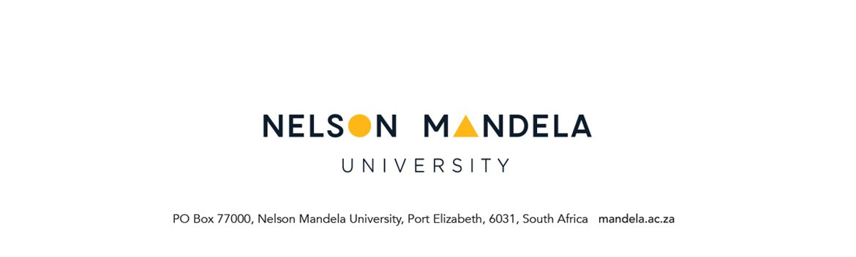

STUDENT REQUEST FORM

PERSONAL DETAILS OF APPLICANT
STUDENT NUMBER | QUALIFICATION NAME
SURNAME | INITIALS
STUDY ADDRESS | CONTACT DETAILS
Code: | Tel. nr. (home)  Tel. nr. (work)  Cell  E-mail

REQUESTED: (Please mark with X next to relevant one)

Additional / excessive Credits
Concurrent registration of modules on different study periods (where pre-requisites are applicable)
Concurrent registration for two qualifications
Waiver of prerequisites
Any other request ( mark & indicate below)
Appeal for assessment opportunity (specify module details below)
Module(s) requested

MOTIVATION (attach a separate motivation if space provided below is not sufficient)
………………………………………………………………………………………………………………………………………………………………………………………………………………………………………………………………………………………………………………………………………………………………………………………………………………………………………………………………………………………………………………………………………………………………………………………………………………………………………………………………………………………………………………………………………………………………………………………………………………………………………………………………………………………………………………………………
………………………………………………………………………………………………………………

………………………………… …………………………
Student signature Date

FOR OFFICE USE

RECOMMENTATION: FACULTY ADMINISTRATION
- FA to indicate the status of the student record & attach CCL
- FA to Indicate whether request supported / not supported
- FA to indicate whether request will require consultation with Service Faculty

………………………………………………………………………………………………………………………………………………………………………………………………………………………………………………………………………………………………………………………………………………………………………………………………………………………………………………………………………………………………………………………………………………………………………………

………………………………. ……………………

Staff signature Date
____________________________________________________________________________

APPROVAL: HEAD OF DEPARTMENT
- Hod to indicate reason(s) where request is NOT approved

………………………………………………………………………………………………………………………………………………………………………………………………………………………………………………………………………………………………………………………………………………………………………………………………………………………………………………………………………………………………………………………………………………………………………………

………………………………. …………………
Staff signature Date
____________________________________________________________________________

APPROVAL: FMC (where applicable)
- FA to indicate reason(s) where request is NOT approved
- FA to indicate outcome of Service Faculty consultation (where applicable)

………………………………………………………………………………………………………………………………………………………………………………………………………………………………………………………………………………………………………………………………………………

 | Yes / NO /Sign | Date
Captured on ITS
Remarks on student record
Student notified

