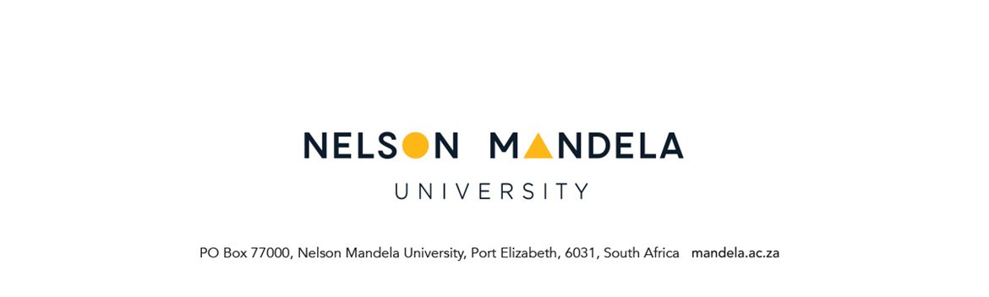APPLICATION FOR RECOGNITION OF MODULE CREDITS

PERSONAL DETAILS OF APPLICANT
STUDENT NUMBER | NAME OF DEGREE/DIPLOMA
SURNAME | FULL NAMES
STUDY ADDRESS | CONTACT DETAILS
Code: | Tel. nr. (home)  Tel. nr. (work)  Cell  E-mail:
PARTICULARS OF MODULE(S) FOR OFFICE USE
Name of module passed at another institution | Name of Nelson Mandela University module to be recognised for credit | Nelson Mandela University module code | HOD Signature | Yes/  No*

IS THIS THE FINAL MODULE(S) TOWARDS YOUR QUALIFICATION? | YES | NO

Student signature: ………………………………….. Date: ………………………..

PLEASE INCLUDE:
1. ORIGINAL ACADEMIC RECORD(S) / RESULT STATEMENT showing proof of modules passed.
2. SYLLABI in case of modules passed at another institution e.g. University.
3. FEES – Debited onto the student account (only applicable if modules were passed at another institution)
Not refundable – irrespective of the outcome of the application.
4. Students registered at the University should continue attending classes while awaiting the outcome of the application.

FOR OFFICE USE
Captured: | Student Notified:
Initial: Date: | Initial: Date:
*Reason for non-approval of request for recognition of module credit application (HOD to complete)
……………………………………………………………………………………………………….

……………………………………………………………………………………………………….

