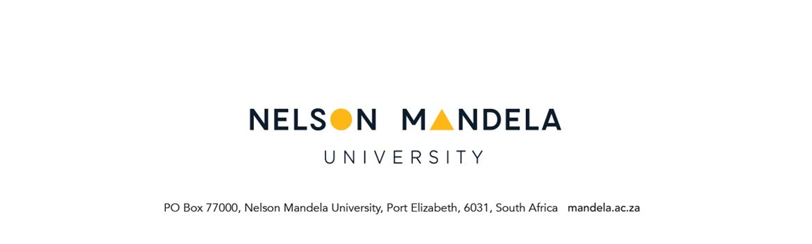

STUDY ELSEWHERE APPLICATION

PERSONAL DETAILS OF APPLICANT
STUDENT NUMBER | NAME OF DEGREE/DIPLOMA
SURNAME AND TITLE (Mr / Ms) | INITIALS
STUDY ADDRESS | CONTACT DETAILS
Code: | Tel. nr. (home)  Tel. nr. (work)  Cell  E-mail
NOTE: Rule G1.4.3 A candidate shall be required to complete all the exit level modules at the University, provided that the Faculty Management Committee (FMC) may approve that not more than half of the total credit value of the exit level modules may be completed at another institution. ECS on recommendation of FMC may approve a deviation in respect of more than half of the total credit value of the exit level modules.

Please include the following with the application:
- Full Nelson Mandela University academic record (obtainable from Student Records / Information Office)
- Syllabi of modules to be studied at the other institution (to be obtained from the other Institution)
- Receipt for study elsewhere fee – payable at any Nelson Mandela University cashier or via internet banking. Non-refundable, irrespective of the outcome of the application.
- Please allow 2 weeks for processing

Banking details:
Bank: Standard Bank
Branch: Rink Street, Port Elizabeth
Branch code: 050417
Account name: NMMU Main
Account no: 08 026 3011
Reference: BX followed by student number

Please indicate for when application must be considered.
Start of 2nd semester | January 20……………

MODULE(S) TO BE STUDIED AT THE OTHER INSTITUTION

MODULE NAME | Nelson Mandela University  MODULE CODE | OTHER UNIV. MODULE CODE | MODULE  CREDIT VALUE | HOD  YES/NO &  SIGNATURE

NAME OF OTHER INSTITUTION:…………………………………………………………….........

REASON WHY MODULE(S) CANNOT BE DONE AT NELSON MANDELA UNIVERSITY

………………………………………………………………………………………………………………………………………………………………………………………………………………………………………………………………………………………………………………………………………………………………………………………………………………………………………………………………
………………………………………………………………………………………………………………………………………………………………………………………………………………………………………………………………………………………………………………………………………………………………………………………………………………………………………………………………

……………………………………….. …………………………
Student signature Date

For office use only:
% of programme to be done elsewhere
% exit levels to be done elsewhere
Approved
Entered on SREGB – 1

