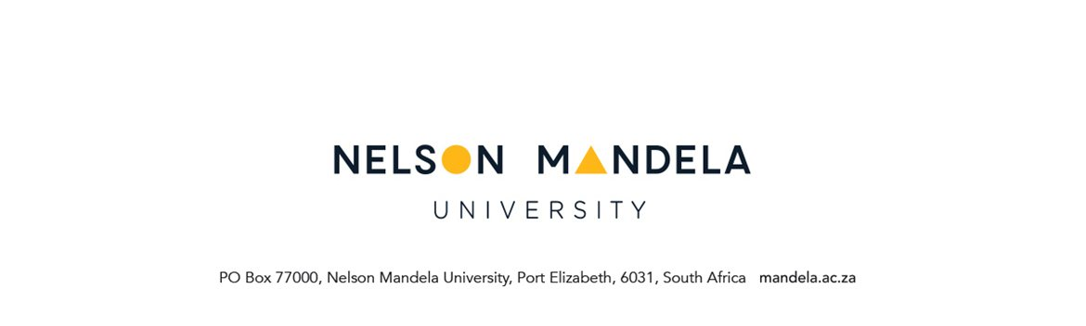

**CHANGE OF QUALIFICATION OR PROGRAMME**

**FOR NELSON MANDELA UNIVERSITY REGISTERED STUDENTS**

**PERSONAL DETAILS**

|  |  |  |  |  |
| --- | --- | --- | --- | --- |
| Student number | | | | |
| Title | Initial | | Surname | |
| First Names in full | | | | |
| Maiden name (if applicable) | | | | |
| Marital Status | | | | Identity number |
| Single | | Married | |

**COMMUNICATION DETAILS**

|  |  |  |  |
| --- | --- | --- | --- |
| **POSTAL ADDRESS** | | **STUDY ADDRESS** | |
|  | |  | |
| Postal code |  | Postal code |  |
| E-mail address: | | | |
| Telephone number: (Code) Number | | | |
| Cell number: | | | |

**QUALIFICATION DETAILS**

|  |  |
| --- | --- |
| Current degree/diploma |  |
| Proposed degree/diploma |  |
| Campus |  |
| Curriculum (if applicable) |  |

**Please indicate date of change**

|  |  |  |  |  |  |  |
| --- | --- | --- | --- | --- | --- | --- |
| Immediately |  | Start of 2nd semester |  | January 20…………… | Full-time | Part-time |

**Have a previously applied to change your qualification?**

|  |  |
| --- | --- |
| **Yes** | **No** |
|  |  |

**Kindly read the General Rules below pertaining to change of qualification or programme**

**Extract of General Rules pertaining to change of qualification or programme**.

|  |  |
| --- | --- |
| ***G1.4.10*** | ***Change of qualification or programme:*** |
| ***G1.4.10.1*** | A student applying for a change of qualification or programme, must apply in writing to the Faculty Academic Administration Section by the date published in the General Prospectus of the University. The relevant application form is available on the student portal (online) and from the Faculty Academic Administration Section. |
| ***G1.4.10.2*** | Applications will be subject to selection by the relevant academic department. It is the student’s responsibility to apply for recognition of credits already completed. |
| ***G1.4.10.3*** | The onus remains on the student to ensure that he/she complies with the admission requirements. |
| ***G1.4.10.4*** | The university reserves the right to withdraw an erroneous admission of a student. |
| ***G1.4.10.5*** | A student will be limited to change between incomplete qualifications or programmes  **only once** during his/her studies at the university. |

**QUALIFICATION DETAILS**

|  |  |  |  |  |  |
| --- | --- | --- | --- | --- | --- |
| **CURRENT QUALIFICATION NAME & CODE** | | **NEW QUALIFICATION NAME & CODE** | | | **SIGNATURE OF HOD** |
| CANCEL MODULES | RETAIN  MODULES | ADD  MODULES | OFFERING  TYPE | BLOCK  CODE |
|  |  |  |  |  |  |
|  |  |  |  |  |  |
|  |  |  |  |  |  |
|  |  |  |  |  |  |
|  |  |  |  |  |  |
|  |  |  |  |  |  |
|  |  |  |  |  |  |
|  |  |  |  |  |  |

***NOTE: Permission to add module must be obtained from relevant lecturer/HOD once lectures have commenced.***

**REASONS WHY YOU WISH TO CHANGE TO ANOTHER FIELD OF STUDY**

………………………………………………………………………………………………………………………………………………………………………………………………………………………………………………………………………………………………………………………………………………………………………………………………………………………………………………………………………………………………

**RECOGNITION OF MODULE CREDITS (module exemptions)**

Indicate codes for the modules which you want to apply for module exemption in the proposed degree/diploma:

……………………………………………………………………………………………………………………………………………………………………………………………………………………………………….……..

**DEGREE/ DIPLOMA /CERTIFICATES OF PREVIOUS QUALIFICATIONS:**

**Degree/Diploma/Certificates Institution Attended from to**

|  |  |  |  |
| --- | --- | --- | --- |
|  |  |  |  |
|  |  |  |  |
|  |  |  |  |
|  |  |  |  |

***CERTIFIED COPIES OF FORMAL ACADEMIC QUALIFICATIONS, ACADEMIC RECORDS AND MATRIC RESULTS MUST BE SUBMITTED WITH THE APPLICATION***

**DECLARATION BY APPLICANT**

I hereby declare that I am aware of:

* The minimum requirements for the proposed qualification/programme
* The minimum requirements of the study for the purpose of renewal of registration (see prospectus)
* I confirm that I have read/noted/understand the applicable rules below.

…………………………………… ………………………………

STUDENT SIGNATURE DATE

**FOR OFFICE USE:**

**Yes No Comments**

|  |  |  |  |  |
| --- | --- | --- | --- | --- |
| Does the candidate quality for full exemption? |  |  |  | |
| If No, give reason |  | | | |
| Does the candidate comply with the admission requirements for the proposed degree/diploma |  |  |  | |
| If No, give reason |  | | | |
| Applicant Score | Obtained by applicant |  | Required for admission |  |
| Academic record attached |  |  |  | |
| Matric results attached |  |  |  | |

**RECOMMENDATION BY FACULTY ACADEMIC ADMINISTRATION CONSULTANT**

|  |  |
| --- | --- |
| Accepted | Not Accepted |

**Comments:** ………………………………………………………………………………………………………………………………………………………………………………………………………………………………………………

Signature of FAAC______________________ Date: _________________________

**FAAC Check List Initial & Date**

|  |  |  |
| --- | --- | --- |
|  | |  |
|  | |  |
| **Score sheet printed** |  | |
| **SNAPPA record created** |  | |
| **Letter issued** |  | |

**RECOMMENDATION BY HEAD OF DEPARTMENT (if applicable)**

|  |  |
| --- | --- |
| Accepted | Not Accepted |

**Comments:** ………………………………………………………………………………………………………………………………………………………………………………………………………………………………………………

Signature: ____________________ Date:__________________________

**RECOMMENDATION BY FINANCIAL AID**

|  |  |
| --- | --- |
| Recommended | Not Recommended |

**If NOT Recommended, please state reasons why:**

**………………………………………………………………………………………………………………………………………………………………………………………………………………………………………………………………………………………………………………………………………………………………………………………………………………………………………………………………………………………………………………………………………………………………………………………………………………………**

……………………………….…… ………….. ………………………………

**Signature by Financial Aid Staff member DATE**