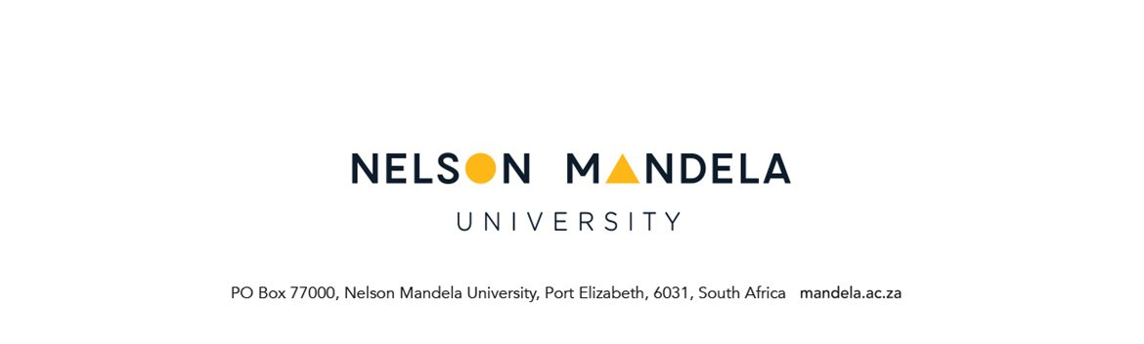
FACULTY OF HEALTH SCIENCES
RESEARCH SCHEDULE OF SUBMISSION OF AGENDA ITEMS TO THE
FACULTY POSTGRADUATE STUDIES (FPGSC) MEETING

Title

Author and position

SUBMISSION CONTENT

Detail and motivation for request

Attachments (List of supporting documents related to submission)

Approvals
Author of Submission | Name | Signature | Date
FPGSC/FREC Chairperson | Name | Signature | Date
Faculty Approval | Name | Signature | Date

1. FPGSC Masters and Doctoral Academic Administration agenda items:
Please submit the completed form and supporting documents to:
Fundiswa.Qangule@mandela.ac.za and Marilyn.Afrikaner@mandela.ac.za
2. FPGSC proposal/FREC agenda items:
Please submit the completed form and supporting documents to:
Thembeka.Sdinane@mandela.ac.za and Zukile.Sifile@mandela.ac.za

