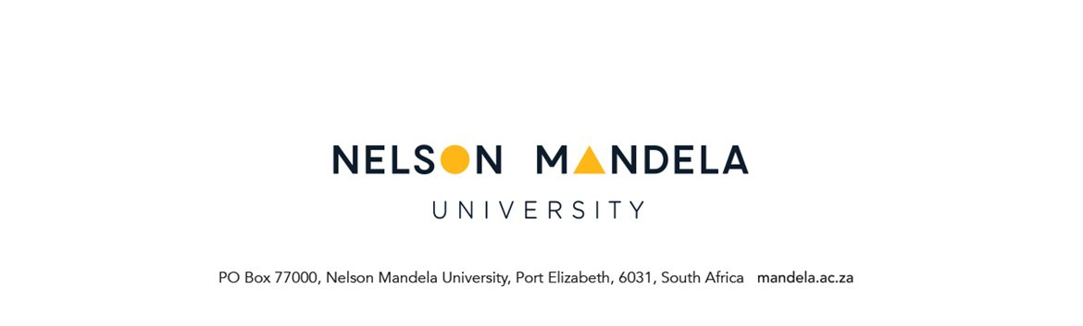

REQUEST TO REGISTER A MODULE AFTER THE DEADLINE
Applicable to all programmes and for use after the deadline for late registration.

SECTION A
PERSONAL DETAILS OF STUDENT
STUDENT NUMBER | NAME OF DEGREE/DIPLOMA
SURNAME | INITIALS
STUDY ADDRESS | CONTACT DETAILS
Code: | Tel. nr. (home)  Tel. nr. (work)  Cell:  E-mail

MODULE ADDITIONS

MODULE CODE | LECTURER’S SIGNATURE AS CONFIRMATION THAT STUDENT HAS ATTENDED LECTURES |  | MODULE CODE | LECTURER’S SIGNATURE AS CONFIRMATION THAT STUDENT HAS ATTENDED LECTURES

MOTIVATION FOR LATE ADDITION OF MODULE/S

……………………………………………………………………………………………………………………

……………………………………………………………………………………………………………………

……………………………………………………………………………………………………………………

……………………………………………………………………………………………………………………

……………………………………………………………………………………………………………………

…………………………………………….. ……………………
Student signature Date

SECTION B

RECOMMENDATION: FACULTY ADMINISTRATOR

……………………………………………………………………………………………………………………

……………………………………………………………………………………………………………………

…………………………………………….. ……………………
Staff signature Date

SECTION C

RECOMMENDATION/ DECISION: FACULTY MANAGER

……………………………………………………………………………………………………………………

……………………………………………………………………………………………………………………

…………………………………………….. ……………………
Staff signature Date

SECTION D

DECISION: SENIOR MANAGER/ DEPUTY DIRECTOR

……………………………………………………………………………………………………………………

……………………………………………………………………………………………………………………

…………………………………………….. ……………………
Staff signature Date

PLEASE NOTE THAT A FEE WILL BE CHARGED FOR LATE REGISTRATIONS

