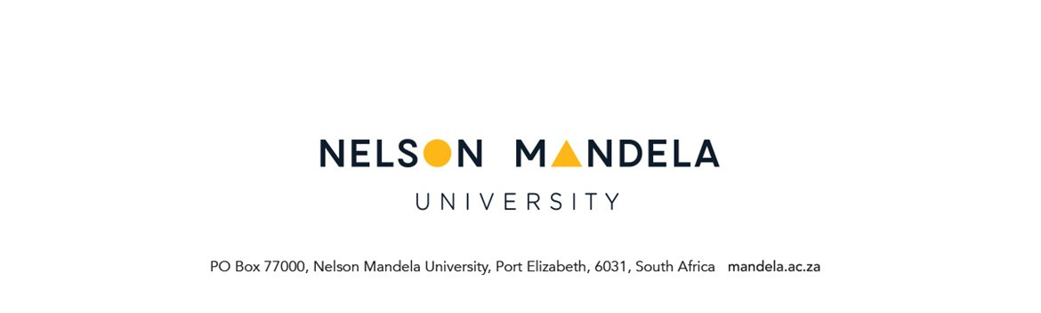

STUDENT REQUEST FORM

PERSONAL DETAILS OF APPLICANT
STUDENT NUMBER | QUALIFICATION NAME
SURNAME | INITIALS
STUDY ADDRESS | CONTACT DETAILS
Code: | Tel. nr. (home)  Tel. nr. (work)  Cell  E-mail

REQUESTED: (Please tick one) √

1.Additional / excessive Credits  a) What are the credits you are currently registered for?  b) What are the module credits that you would like to add. Please indicate the module code and module description.  c) Reason for requesting excessive credits registration. | a) Registered credits:  b) Module Code:  Module description:  Module additions total credits:  c) Reason/Motivation for excessive credits registration:
2.Concurrent registration of modules on different study periods (where pre-requisites are applicable)
3.Waiver of pre-requisites
- Module you are requesting to register for:
Please indicate the module code and
module description
- What is/are the pre-requisite module you
did not pass. Please indicate the
module code and module description
4.Appeal for assessment opportunity
a) Please indicate the module code and
module description
5. Concurrent registration for two qualifications
6. Any other request (mark & indicate below)

MOTIVATION (attach a separate motivation if space provided below is not sufficient)
………………………………………………………………………………………………………………………………………………………………………………………………………………………………………………………………………………………………………………………………………………………………………………………………………………………………………………………………………………………………………………………………………………………………………………………………………………………………………………………………………………………………………………………………………………………………………………………………………………………………………………………………………………………………………………………………
……………………………………………………………………………………………………………………………………………………………………………………………………………………………………………………………………………………………………………………………………………………………………………………………………………………………………………………………………………………………………………………………………………………………....……………………………………………………………………………………………………………………………………………………………………………………………………………………………………………………………………………………………………………………………………………....………………

………………………………… …………………………
Student signature Date

FOR OFFICE USE

RECOMMENTATION: FACULTY ADMINISTRATION
- FA to indicate the status of the student record & attach CCL
- FA to Indicate whether request supported / not supported
- FA to indicate whether request will require consultation with Service Faculty

………………………………………………………………………………………………………………………………………………………………………………………………………………………………………………………………………………………………………………………………………………………………………………………………………………………………………………………………………………………………………………………………………………………………………………………………………………………………………………………………………………………………………………………………………………………………………………………………………………

………………………………. …………………………

Staff signature Date

____________________________________________________________________________

APPROVAL: HEAD OF DEPARTMENT
- Hod to indicate reason(s) where request is NOT approved

………………………………………………………………………………………………………………………………………………………………………………………………………………………………………………………………………………………………………………………………………………………………………………………………………………………………………………………………………………………………………………………………………………………………………………………………………………………………………………………………………………………………………………………………………………………………………………………………………………

………………………………. ……………………….
Staff signature Date

APPROVAL: FMC (where applicable)
- FA to indicate reason(s) where request is NOT approved
- FA to indicate outcome of Service Faculty consultation (where applicable)

………………………………………………………………………………………………………………………………………………………………………………………………………………………………………………………………………………………………………………………………………………………………………………………………………………………………………………………………………………………………………………………………………………………………………………………………………………………………………………………………………………………………

 | Yes / NO /Sign | Date
Captured on ITS
Remarks on student record
Student notified

