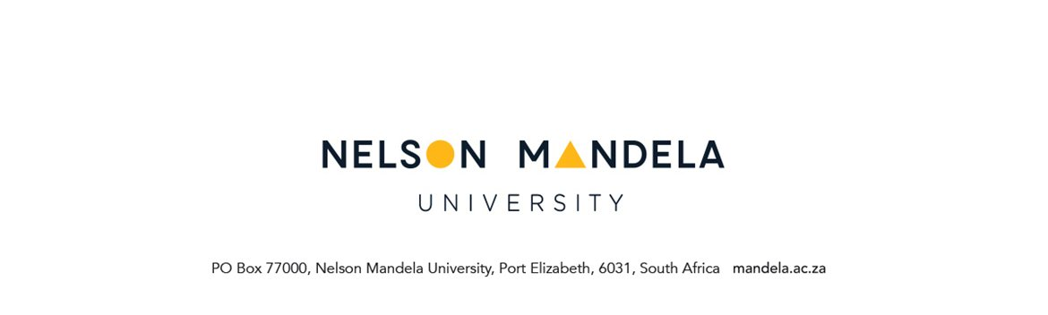

APPEAL TO REGISTER AFTER THE DEADLINE
Applicable to all programmes and for use after the deadline for late registration

SECTION A
PERSONAL AND QUALIFICATION DETAILS OF STUDENT
STUDENT NUMBER | NAME OF QUALIFICATION TO BE REGISTERED | FULL-TIME / PART-TIME
SURNAME | INITIALS | LAST REGISTRATION YEAR
STUDY ADDRESS | CONTACT DETAILS
Code:
Appeal forms will only be provided to students during the 2 weeks following the last day for late registration and registration changes.

NB: You must ensure that all your financial obligations have been met. You must have attended lectures (where applicable)

NO APPEALS WILL BE ENTERTAINED OR CONSIDERED AFTER THE END OF APRIL.

- Please note that as you are late you have missed the centralized and late registration processes. You are now following the extended, manual registration appeals process.
- Complete Section A and Section B, provide/attach a motivation for your request and sign at the bottom of page 2 (section B).
- Attach all supporting documents (where applicable)
- Email this form back to your Faculty Academic Administration Consultant / PG Consultant who will initiate the process on your behalf.
- Notify your lecturer that you have appealed for late registration and you are waiting for a decision regarding your appeal (where applicable).
- The outcome of the application will be communicated to you via e-mail by the Faculty Academic Administration /Postgraduate Consultant.

MOTIVATION FOR REQUEST (You may attach motivation as a separate document if needed)

……………………………………………………………………………………………………………………

……………………………………………………………………………………………………………………

……………………………………………………………………………………………………………………

……………………………………………………………………………………………………………………

SECTION B

REGISTRATION FORM (YEAR _______) (indicate year here)

REGISTRATION DETAILS
INDICATE MODULES TO BE REGISTERED
AND / OR
CONFIRMATION OF ATTENDANCE BY LECTURER(S)

MODULE CODE | Attended lecture Y/N | LECTURER’S SIGNATURE AS CONFIRMATION THAT STUDENT ATTENDED LECTURES  (Not applicable to treatise module / Research M & Ds) | MODULE CODE | Attended lecture Y/N | LECTURER’S SIGNATURE AS CONFIRMATION THAT STUDENT ATTENDED LECTURES  (Not applicable to treatise module / Research M & Ds)

________________________ _____________________
Student signature Date

PLEASE EMAIL FORM BACK TO YOUR FACULTY ACADEMIC ADMINISTRATION ONCE SECTION A HAS BEEN COMPLETED

SECTION C

RECOMMENDATION: FACULTY ACADEMIC ADMINISTRATION

Date on which student was registered in previous year : --------------------------------------------

Did student apply for late registration in previous year : …………………………………….

If Yes, was student issued with a formal letter: ……………………………..……..

Date form was given to student: ……………………………………..

Comments:
……………………………………………………………………………………………………………………

…………………………………………….. ……………………
Staff signature Date

SECTION D

RECOMMENDATION: DIRECTOR OF SCHOOL / HEAD OF DEPARTMENT

……………………………………………………………………………………………………………………

…………………………………………….. ……………………
Staff signature Date
SECTION E
FINANCE DEPARTMENT

Student finances are in order: YES / NO

……………...…………………………………………………………………………………………………….

……………...…………………………………………………………………………………………………….

…………………………………………….. ……………………
Staff signature Date

SECTION F

RECOMMENDATION: OFFICE FOR INTERNATIONAL EDUCATION (for international students only)

……………………………………………………………………………………………………………………

……………...…………………………………………………………………………………………………….

…………………………………………….. ……………………
Staff signature Date

SECTION G

RECOMMENDATION : DEPUTY DIRECTOR: FACULTY ACADEMIC ADMINISTRATION

……………………………………………………………………………………………………………………

……………...…………………………………………………………………………………………………….

…………………………………………….. ……………………………..
Staff signature Date

DECISION : DIRECTOR ACADEMIC ADMINISTRATION

……………………………………………………………………………………………………………………

…………………………………………….. ……………………………..
Staff signature Date

